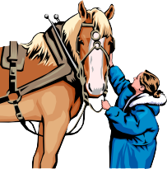

2026 4-H BAYOU AREA HORSE SHOW
June 6, 2026 Lafourche Parish Horse Arena
Covered Facility
Registration Starts at 9 A.M. & Competition Begins at 10 A.M. USE ONE FORM FOR EACH HORSE ENTRY
Exhibitor’s Parish
Exhibitor's Name Exhibitor's Date of Birth Name of Horse Breed Registration # Date Foaled
Please check numbers of classes you wish to enter: $5.00 per event if entered by May 22, 2026
$7.00 per event entered after May 22, 2026
Make checks payable to: Lafourche 4-H Foundation. Mail or drop off registration and fees to: LSU AgCenter, Bayou Area Horse Show, 115 Texas St., Raceland, LA 70394

Order of Events

1. Showmanship, 14 & Over
2. Showmanship, 13 & Under
3. Appaloosa Geldings, All Ages
4. Appaloosa Mares, All Ages
5. Quarter Horse Geldings, All Ages
6. Quarter Horse Mares, All Ages
7. Paint Horse Geldings, All Ages
8. Paint Horse Mares, All Ages
9. Arabian Horse Geldings, All Ages
10. Arabian Horse Mares, All Ages
11. Miniature Horse Geldings, All Ages
12. Miniature Horse Mares, All Ages
13. AOB & Grade Geldings, All Ages
14. AOB & Grade Mares, All Ages
15. Western Pleasure, 14 & Over
16. Western Pleasure, 13 & Under
17. Western Horsemanship, 14 & Over
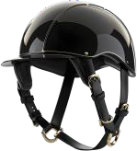
18. Western Horsemanship, 13 & Under
19. Barrel Racing, 14 & Over
20. Barrel Racing, 13 & Under
21. Texas Barrel Racing, 14 & Over
22. Texas Barrel Racing, 13 & Under
23. Pole Bending, 14 & Over
24. Pole Bending, 13 & Under
Please Note: Safety helmets and boots are REQUIRED!
25. Stakes, 14 & Over
26. Stakes, 13 & Under

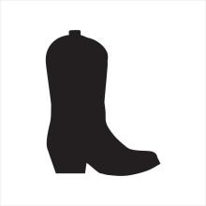
THERE WILL BE A FUN EVENT OFFERED FOR $10!

Please include a copy of the horse's negative Coggin’s test.
(Check if applicable) I will be participating in the FUN EVENT.
THE PREMIER EXHIBITOR CONTEST IS OPEN TO ALL AGE GROUPS!

(Check if applicable): I am competing in the Premier Exhibitor Contest.
By signing below, I acknowledge that I am familiar with the rules and regulations of the Louisiana 4-H Horse Shows and agree to abide by them. I have the permission of my parent(s) or guardian(s) to attend and participate in this show. I, with my parent(s) or guardian(s), will not hold Louisiana State University or any of its employees responsible for injury or otherwise to persons or animals exhibiting at the show.

Signature of parent/guardian Signature of 4-H member
Address of Exhibitor Zip Exhibitor's Phone Number

PERFORMANCE AND SPEED CHAMPION AND RESERVE CHAMPION BUCKLES (JR. AND SR.) WILL BE
AWARDED!
- Tie Breaker will be determined by LSU Catalog Rules. If that does not break the tie, a coin flip will be used.
- Everyone will receive a prize! If you can’t stay to get your prize, please ensure someone picks it up for you.

